Registration form for:

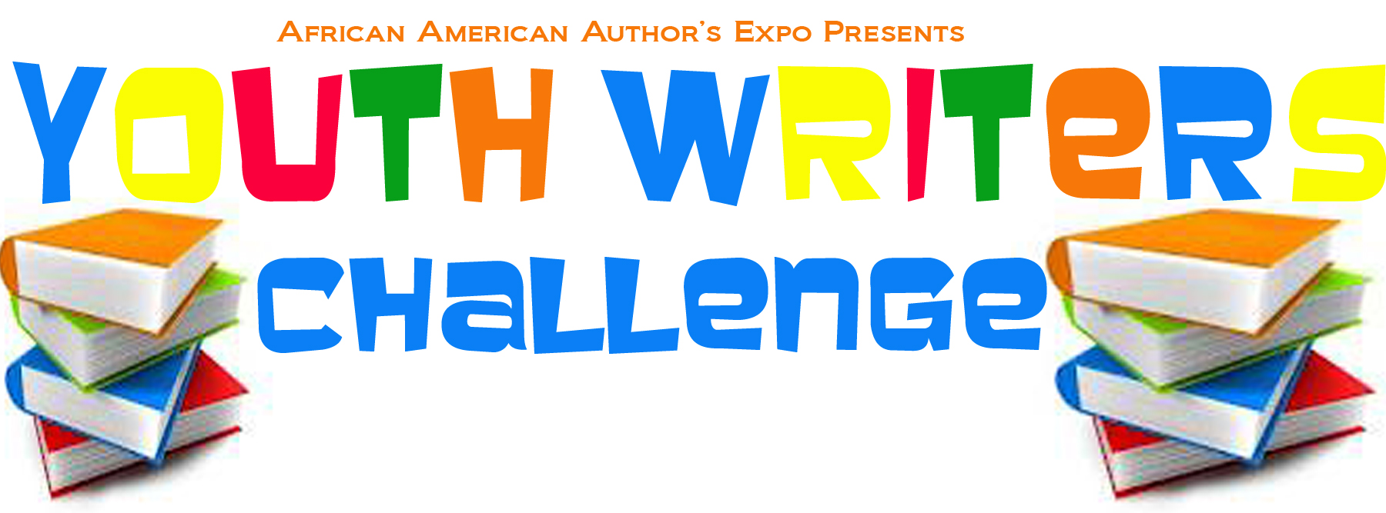
Writers Rock Program
January 7, 2017 – June 17, 2016
Enoch Pratt Library – Weaverly Branch
400 E 33rd St, Baltimore, MD 21218
*** Students must pre-register with this form. Registration
must be submitted no later than November 30, 2016
Email:pjohnson@youthwriterschallenge.org or fax form to 443-757-1011

Student name: _____________________________________________Age:___________
Address: __________________________________________________________________

City___________________________________ State_______________________________

Grades 4th- 6th __________ Grades 7-9^{th_____________} Grades 9th– 12th ___________

School Name _______________________________________________________________

Phone: ___________________________ Email: ________________________________

Parent/Guardian Name:_________________________________Phone: _________________

Parent/Guardian Email: ________________________________________________________

** Important things to remember**

- Writers Rock Program meets every Saturday from January 7, 2017 until June 17, 2017
- Writers Rock Program meets every Saturday from10:00am until 1:00pm
- Each student will be required to sign a Behavioral Contract
- Each parent and student will be required to sign a confidential agreement
- Each student will submit a photo and short bio(300 words or less) for website

Youth Writers Rock Tee Shirt Size S_____ M____ L_____ XL_____

___I herby agree that all submission is sole creations of the student.

Student Signature_____________________________________________

Parent Signature ______________________________________________

